**Project proposal**

**Project Name:** Flower Power

**Project Team:** Alex Davidoff, Noah Reid, Casey Elder, Vishal Ramisetty

**Problem Statement:**

The problem that the team is trying to solve is that flowers can only be identified by individuals with some experience in botany, or by those who own a document or book which assists in identifying flowers.

This is a problem because this makes it difficult for amateur botanists or average people to be able to identify what kind of flower is in front of them. This can be frustrating for those who hunt flowers in their pastime but can also dangerous. Florida alone is home to the spotted water hemlock, oleander, and rosary pea, which are all very pretty—but poisonous—flowers that might fool the uninformed. In addition, there is a great degree of uncertainty with identifying flowers without experience. Roses are red, but they can also be blue, pink, yellow, orange, and many other colors that might confuse someone who otherwise would be absolutely certain that they have identified a rose based on shape. In addition, plant mimicry is very difficult to identify by sight alone. The botanist who wants a hummingbird friendly yard might not realize that the Lobelia Cardinalis, which attracted hummingbirds, is actually very toxic and does not produce nectar. Ideally, the machine learning model will be able to see what humans cannot immediately see and be helpful in identifying tricky flowers.

**Stakeholders:**

The primary stakeholders are trained and amateur botanists who, in addition to their eyes, experience, and books, want an additional way to identify and verify flowers. For the botanist whose most reliable source of information is the Old Farmer’s Almanac or other books, it would be helpful to have a modern approach to flower identification.

The secondary stakeholders are those whose hobbies or professions introduce them slightly into the world of botany. Some examples are hikers, gardeners, and boy scouts. While these secondary stakeholders are not focused on botany, their interests inevitably lead them to the need to identify some plant life, and our tool can help them. Our tool will even be helpful for fisherman, as being able to identify the Nymphaea Lotus, a plant which provides great food for fish, may enhance their fishing experience.

**Proposed Solution:**

The proposed solution consists of the integration of front-end and back-end development to create a user-friendly model for the identification of flowers. The machine learning model will receive a user-uploaded image and identify the flower from a list of twenty pretrained flower types. Additionally, the program will display images of the identified flower species to allow the user to immediately verify the reliability of the model and determine if the identification is correct. The program will also determine the uncertainty of the match and display it as a percentage alongside the identification. The selected flowers are uncommon flowers that the user may be unlikely to visually recognize and are listed below.

Selected flowers for identification:

1. Allium
2. Billbergia
3. Camellia
4. Diascia
5. Eremurus
6. Feverfew
7. Gazania
8. Hellebore
9. Impatients
10. Lobelia Cardinalis
11. Kalmia
12. Lantana
13. Magnolia
14. Nemophila
15. Nymphaea Lotus
16. Peace lily
17. Queen Anne’s Lace
18. Rondeletia
19. Scaevola
20. Tiger Flower

Due to constraints in time and expertise, the machine learning model will be tailored to the above flower types from an algorithm already pretrained to identify a small number of common flowers. Implementing a pretrained model will significantly reduce training time, as the model will already know how to recognize the flower class within object classification broadly. This reduces the number of images required for each of the above flowers in order to effectively train the model.

Importantly, Python’s Anaconda libraries, the Jupyter Notebook IDE, and TensorFlow image processing tools will be used in the back-end development of the program. We will use the Mobile Net V2 model for our image recognition. This algorithm has already been pretrained to recognize common flowers, specifically roses, tulips, daisies, and dandelions. This model is available in the Tensorflow API and requires a single square red-blue-green image as an input. Additionally, the model only accepts JPG/JPEG images.

Therefore, machine learning algorithm implementation from scratch and the mathematics behind the functionality of deep learning algorithms is outside of the scope of this project. Additionally, the recognition of common flowers and flowers outside of the list of above species are also outside of the scope of this project.

**Proposed method to solve the problem:**

The machine learning model will be implemented into an interactive website to allow for ease of use. Implementing the solution into a website allows for streamlined integration of the machine learning model into a UI and would therefore best support program functionality. A preliminary prototype for the user interface is shown in Figure 1 below.

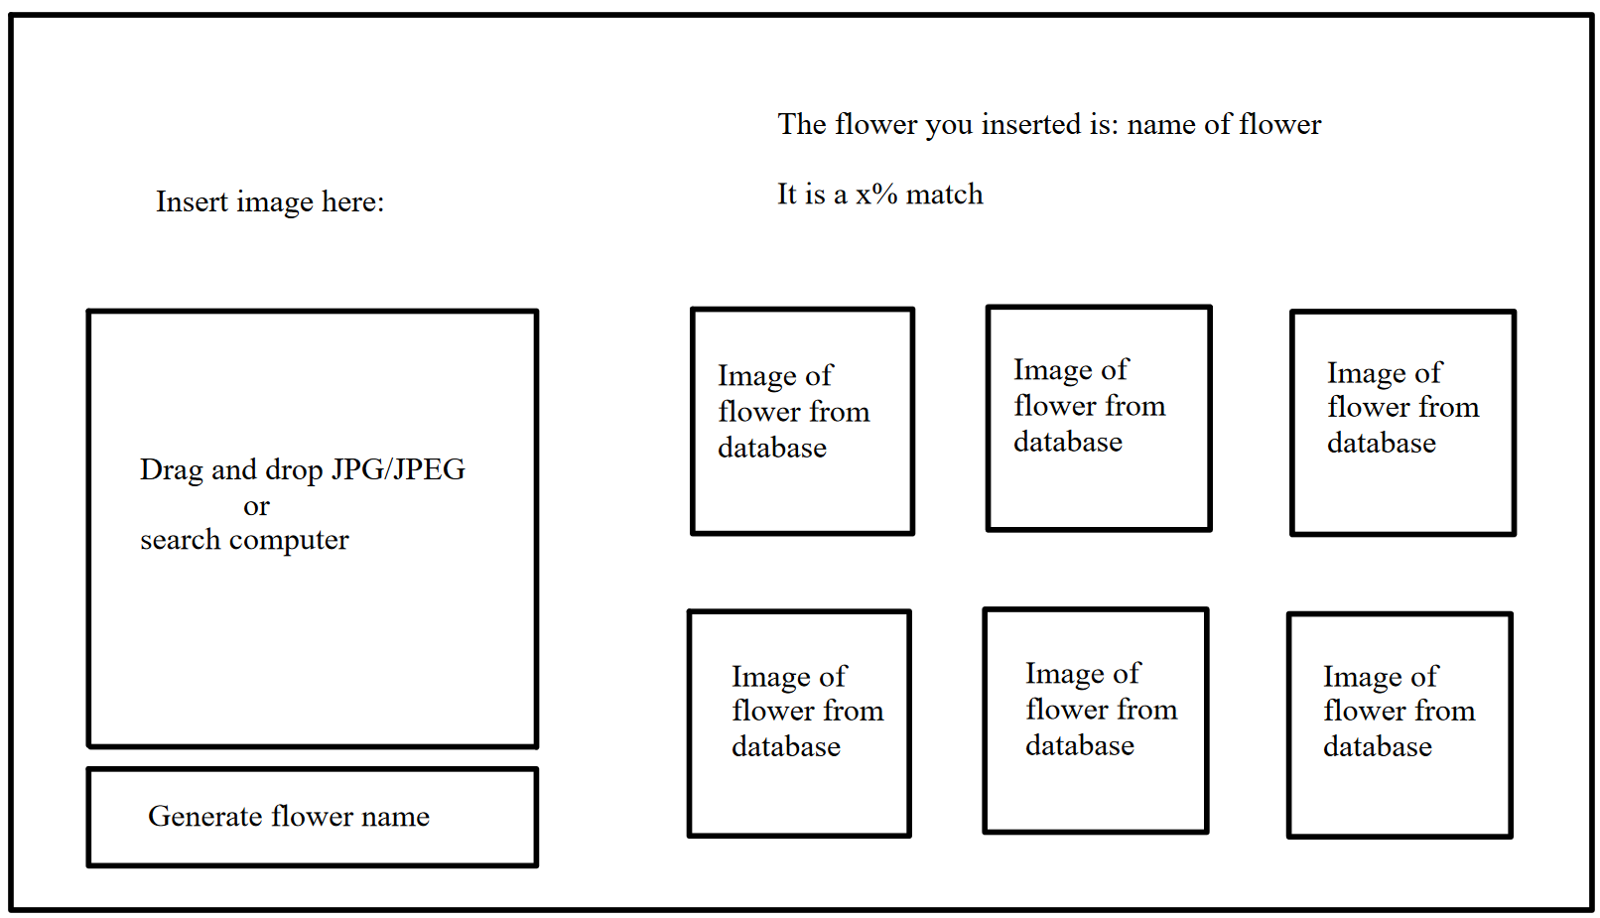Figure 1: Preliminary UI Prototype for the Flower Identification Program.

The user uploads an image of a flower for identification and proceeds to press the “Generate Flower Name” button to submit the image. Internally, the program then resizes the image to a 244 x 244-pixel square image to ease in identification. The program proceeds to identify the flower based on the training sets for the twenty flowers listed in the Proposed Solution section.

Because uncertainty is likely to be introduced, the program will also display how confident it is in the match as a percentage, allowing the user to gauge the reliability of the classification. To further aid in reliability verification, the program will display six images from its own dataset of the identified flower to allow the user to cross check the output with the input. The user is then able to upload a new flower image if they wish to identify a different flower.

Overall, the program receives an image input from the user through the interactive UI, processes the image using a tailored machine learning algorithm, and outputs the estimated flower species, images of the flower species, and confidence level of the identification.